Lecture
Bernhard Rüdiger, Faith Again

Wednesday, November 4, at 5 pm,
FLU Ceremonial Hall, Pariska 16

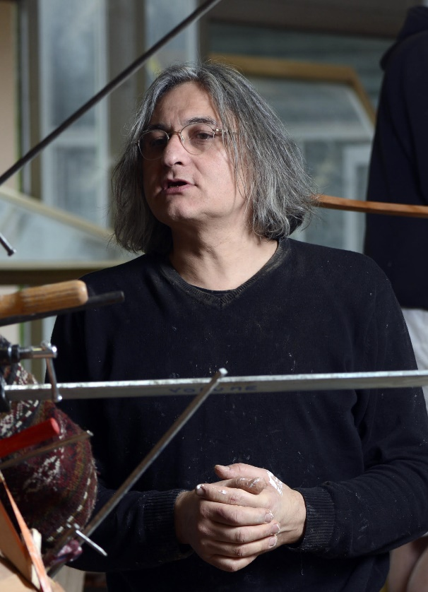
Bernhard Rüdiger
(The photocredit: Luc Jennepin, Montpellier 2015)
Bernhard Rüdiger, Faith Again

The artworks presented in this lecture engage with sound, vibrations, and the bodily experience of the visitor. Their aim is to shift the viewer from a passive to an active role, acknowledging that art is perceived through the whole body and not solely through the eyes. The lecture approaches art as a manifestation that cannot be isolated from historical forces (wars, violence, neoliberal capitalism, and natural disasters) and seeks to analyse how artistic forms are informed and shaped by these events.
The title of the conference was originally intended to be Failed Again (Seventh Trumpet), the title of a recent series of sculptures exploring the possibility of lathing as a response to catastrophe. The title was transmitted orally in preparation for this lecture and subsequently became Faith Again. As someone else remarked, it could also have been Fate Again!
Indeed, we are living in catastrophic times which, like the Seventh Trumpet of the Apocalypse, herald the end of time. Yet this apocalyptic temporality can also be interpreted as an expansion of the present. This lecture proposes understanding our contemporary condition as a positive opportunity to apprehend the increasingly expanded present as a new form of depth, capable of transcending the stagnation of temporalities and our sense of being trapped in a binary opposition between action and inaction.
In this contemporary condition of the expanded present, the question posed by the viewer confronting an artwork is no longer “What do I see?”, as it was in Western modernity, leading the viewer to the subsequent questions: “How do I react?” or “How do I act?” The question facing the contemporary viewer is now: “What should I see?” This is not merely a shift from aesthetics to ethics; it is a question that opens up a new dimension of time. A contemporary artwork is no longer simply the object we see; it also becomes a screen within our inner eye, projecting what we should see. This shift in perception initiates a new process of reflection, understood both as the act of thinking about something and as the mirroring of global power relations, invisible borders, violence, and the economy as the driving force behind contemporary conflicts.

Biography

Born in Rome in 1964, Bernhard Rüdiger has lived and worked in Paris since 1994. His work on space, sound and the physical and perceptive experience of the body is nourished by theoretical reflection on the reality of the work and its historical responsibility. Numerous exhibitions of his work have been held in international institutions. An extensive monograph, Forty-Nine Exhibitions, published in 2022 by Mousse, retraces his career. A retrospective exhibition, Bernhard Rüdiger Failed Again, was shown at the Costal Galleries in Piran, Slovenia, in 2026.
Rüdiger graduate of the Accademia di Belle Arti di Brera with Luciano Fabro, he worked in Milan at La Casa degli artisti, founded by Fabro with Jole De Sanna and Hidetoschi Nagasawa (1978), and played an active part in the debate on the new Italian art scene in the late 1980s. With other artists, including Liliana Moro, Adriano Tovato and Mario Airò, he collaborated on experimental collective projects before founding the magazine tiracorrendo and the Spazio di Via Lazzaro Palazzi (1989-94). In 2022, the Museo del Novecento in Milan created an archive devoted to this work. A book dedicated to this project has been published by Electa in Milan (2022). Rüdiger co-founded the art center Volume! Un lavoro in Via San Francesco di Sales in Rome (1997/1998) with Alfredo Pirri, Jannis Kounellis, philosopher Pietro Montani, and architect Nicola di Battista. In 2004 Rüdiger founded the research unit ACTH, Contemporary Art and Historical Temporalities which he directs at the Art Academy Ensba Lyon. A book of his theoretical texts, Horizon of Forms, The Living Languages of Contemporary Art, was published in the ACTH Artist’s Reflexion collection in 2024.

